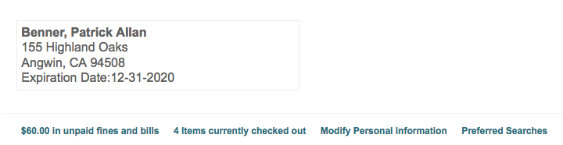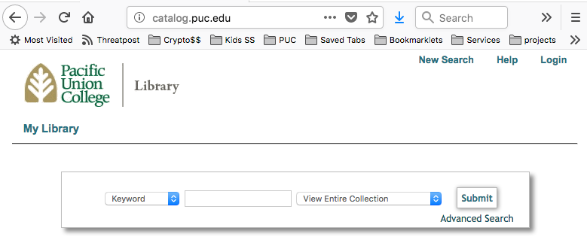

How to sign up for SMS text messages from the library

for help call 707-965-6241 or text 707-948-6639

Step 1: sign into your library account

Step 2: modify person information

Step 3: enter phone# and click Opt in

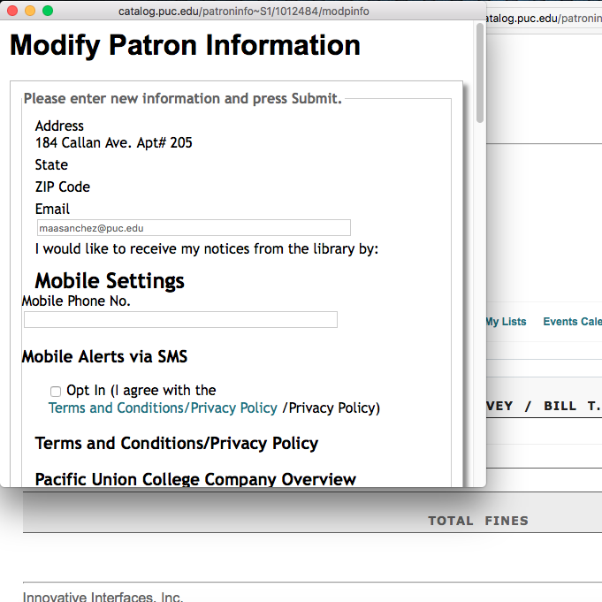

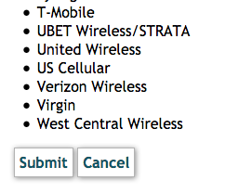

1231231234 or 123-123-1234

…scroll down and click Submit. In about a minute you will get a confirmation text.